

Fundamental of Programming



**Enigma Machine**

**Ahmed Waqar Rao**







# Requirements:



**Project Name Programming Language Compiler**

**Lines**

**Total Functions Classes Objects Pointers Difficulty level**

Enigma machine C++

Visual Studio and Code 420+

17

1

234

2

Hard

**Enigma:-**

It is Encoding and Decoding machine. The Enigma machine was considered so



secure that it was used to encipher the most top-secret messages. The Enigma machine is a cipher device developed and used in the early- to mid-20th century to protect commercial, diplomatic, and military communication.



# Working:-

The Enigma has an electromechanical rotor mechanism that scrambles the 26 letters of the alphabet. In typical use, one person enters text on the Enigma's keyboard and another person writes down which of 26 lights above the keyboard illuminated at each key press. If plain text is entered, the illuminated letters are the encoded ciphertext. Entering ciphertext transforms it back into readable plaintext. The rotor mechanism changes the electrical connections between the keys and the lights with each keypress.

An Enigma machine is made up of several parts including a keyboard, a lamp board, rotors, and internal electronic circuitry. Firstly it has keyboard for Writing purpose contains 26 alphabets and then Lampboard which also 26 Alphabets with lamps inside, next it has Plug board which convert letter into any other if switch is connected, then it has three rotors which is moveable, each rotor has marked from 1 to 26 number, every rotor has internal connection using pin for the sake of letter change, so from rotors letter changed 6 times, next one it has Reflector which is also interchanging letter by once, again this letter go to plug board and changed by once and then go to lamp board, now letter is changed by 9 times which give you cipher text for decoding write the same text with same configuration of rotors then you will get your message.

Enigma was basically a machine developed by the Germans in World War II to encrypt their confidential messages. The beauty of Enigma code is that if you encode "AAA",

the result can be three distinct letters, not something like "JJJ" or "SSS" (if it worked like that then it would have been easy! And the Germans wouldn't have stood a chance!).



# Working:-

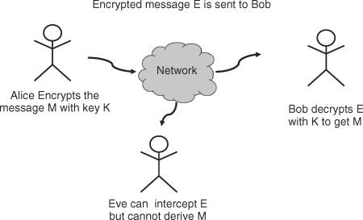

It achieves its functionality with the help of 3 spinning rotors (imagine those locks on briefcases and diaries..). The user is asked to input the spin values for these rotors first.

Then input the text to encode:

Eg:

Enter Spin for Rotor 1: 7

Enter Spin for Rotor 2: 3

Enter Spin for Rotor 3: 9

Enter Text to Send to Your Fellow German Soldier: Hii Ghiyos ud Din(Tajikistan)!

The program will convert everything to uppercase, then will return the gibberish (cipher text), which our enemies will not be able to understand, even if they have an Enigma machine to decode it.

Example Output: IEI OSKS OYNDSM SDF ADO EANFE AODMMQK KAL QTREN KTKT

Unless, they know exactly what spin values we used while encoding, so only if you use those same values again (to decode), you'll get back orignal text:

Enter Spin for Rotor 1: 7

Enter Spin for Rotor 2: 3

Enter Spin for Rotor 3: 9

Enter Text to Send to Your Fellow German Soldier: IEI OSKS OYNDSM SDF ADO EANFE AODMMQK KAL QTREN KTKT Example Output: : Hii Ghiyos ud Din(Tajikistan)!

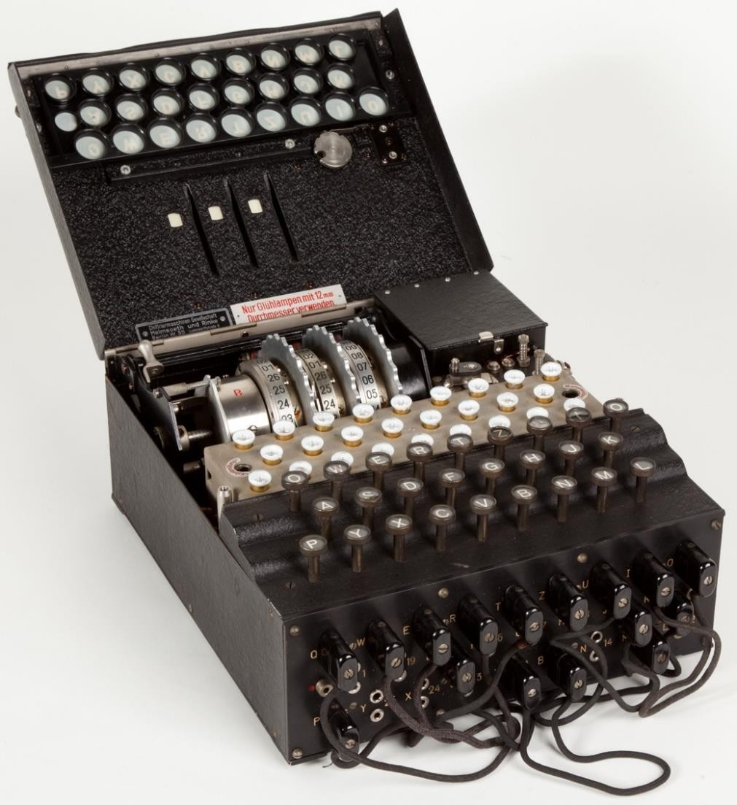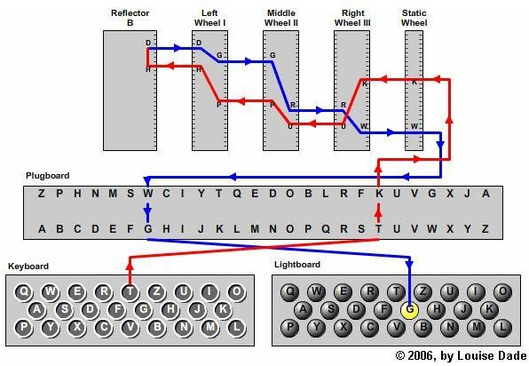





**Keyboard() Lampboard()**

**Rotor1,2,3()**

**Initializing**

**Functions**



# --(UML diagram)--



**Rotor 1,2 and 3**

**Inputs**

**Cin**

**Text**



**Push Back() Spin Increment Output()**



**Remove**

**Spaces()**

**Cipher Text**

**Toupper()**



**Outputs:-**



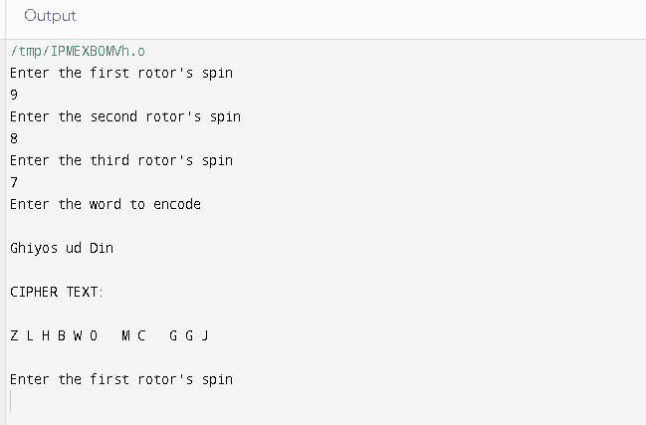





# Outputs:-



